Contents
SQL Server 2022 + SSMS + AdventureWorks2022 Setup (VMware Workstation) 1
AdventureWorks2022 SQL Queries 6

SQL Server 2022 + SSMS + AdventureWorks2022 Setup (VMware Workstation)
Create a Windows VM (2 vCPU, ≥8GB RAM), install SQL Server 2022 Evaluation, install SSMS, and restore AdventureWorks2022 (OLTP).

1) Environment
Virtualization
- VMware Workstation
- Windows VM (Win10/Win11)
VM spec (assessment requirement)
- CPU: 2 vCPU
- RAM: 8GB (or higher)
- Disk: ≥120GB recommended (thin provision ok)
Networking
- NAT (default) used for downloads and general connectivity.
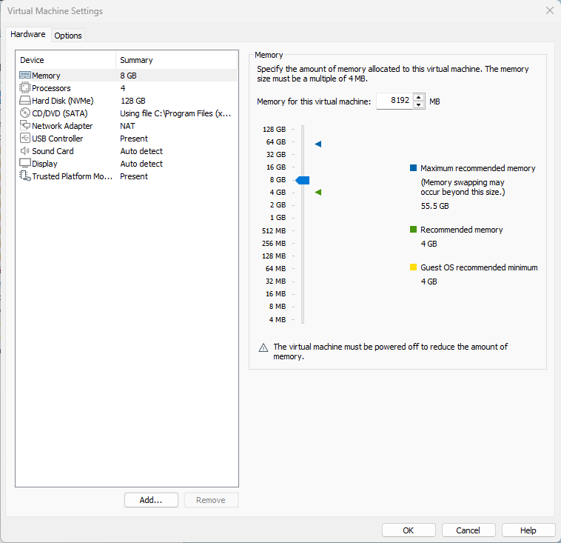

2) Install SQL Server 2022
Installed component
- Database Engine Services (core SQL Server service). (Microsoft Learn)
Installation method
- Installed via the SQL Server Setup Installation Wizard (“New SQL Server stand-alone installation”). (Microsoft Learn)
Key configuration choices
- Instance: Default instance (simple to connect in SSMS)
- Authentication: Mixed Mode (Windows + SQL logins) (none used in this demo)
- SQL Admin: Added my Windows user as a SQL administrator
Verify
- SQL Server service running (Windows Services)
- Can connect locally from SSMS
3) Install SSMS
- Installed SQL Server Management Studio (SSMS) using Microsoft’s installer flow (SSMS installs via the Visual Studio Installer using vs_SSMS.exe). (Microsoft Learn)
Verify
- SSMS opens successfully
- Connects to local SQL instance (localhost / default instance)
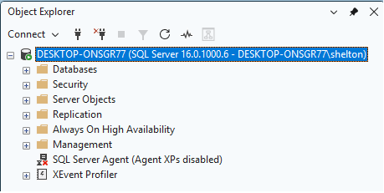
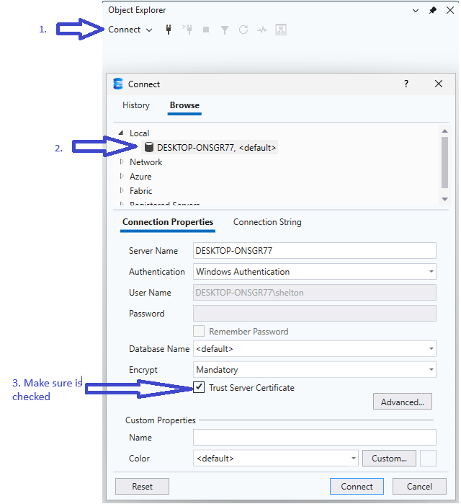

4) Restore AdventureWorks2022 (OLTP)
Database used
- AdventureWorks2022.bak (OLTP). (Microsoft Learn)
Restore method
- Restored using SSMS “Restore Database…” GUI workflow. (Microsoft Learn)
Restore checklist
- Confirmed .bak selected as restore source (Device)
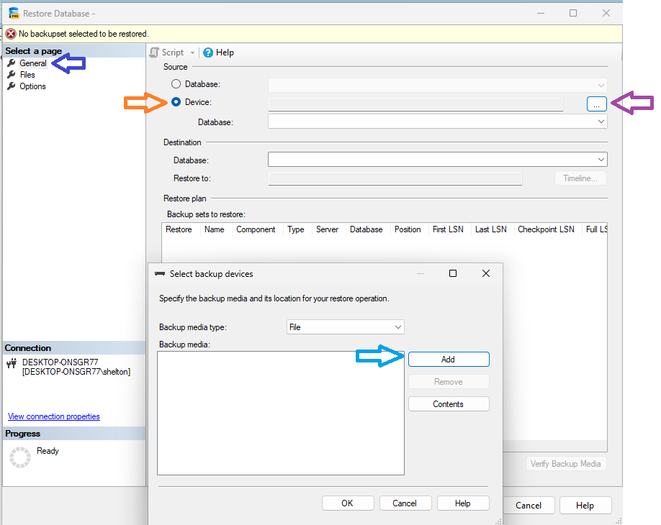
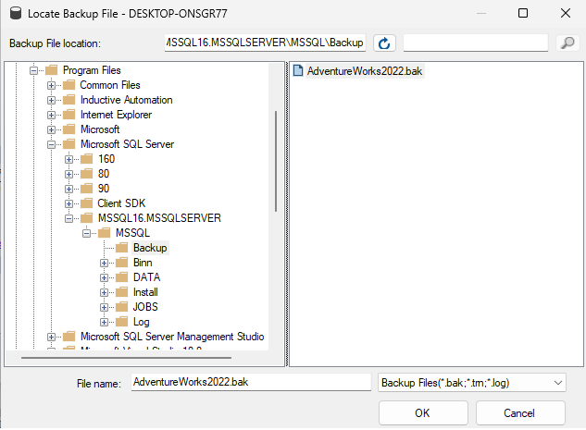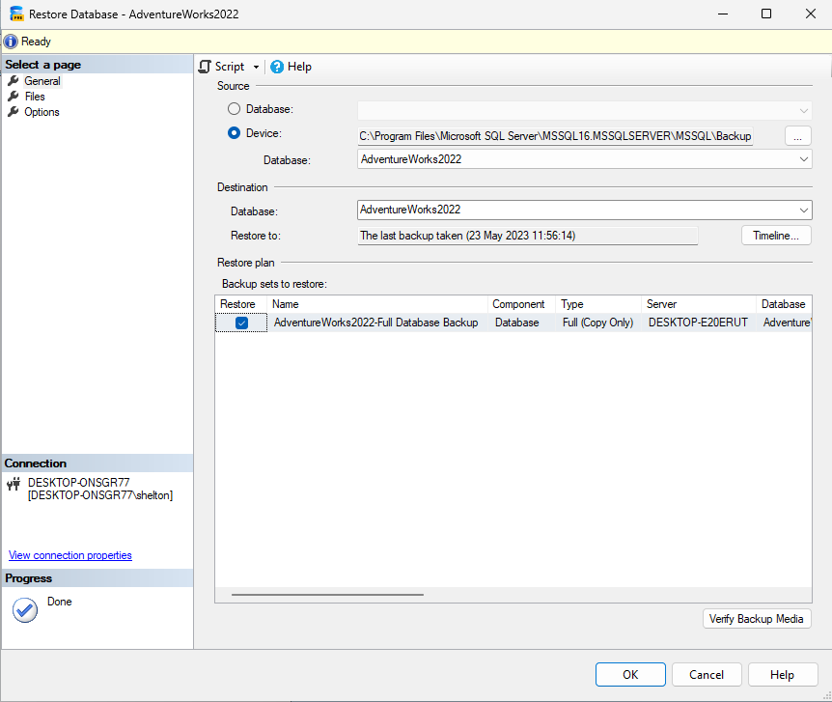
- Checked Files tab for restore locations and file names before running restore (Microsoft Learn)
- Completed restore successfully
Verify
- AdventureWorks2022 appears under Databases
- Tables visible (Sales/Person/Production/HumanResources schemas)
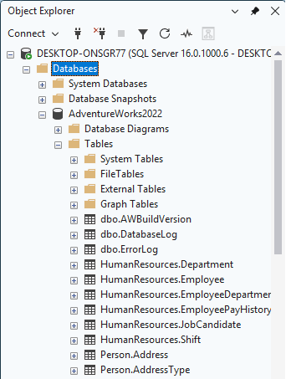

5) Firewall / Ports (Security Note)
For this assessment, all work is performed inside the VM (SSMS in the VM), so no inbound firewall ports are required.
If remote access is ever needed (host → VM), Microsoft recommends using a fixed port (e.g., 1433 for default instance) or creating a program rule, and then configuring Windows Firewall accordingly. (Microsoft Learn)

AdventureWorks2022 SQL Queries
Purpose
This section explains how to prepare, inspect, and query the AdventureWorks2022 SQL
SQL Preparation
Run this first so your queries run in the correct context:
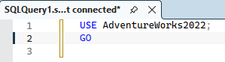
If you don’t, you may get errors like:
Or no entries:
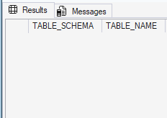

Schema Inspection
Before writing reports, confirm that the tables/views you intend to use actually exist and have the columns you expect.

1) List Relevant Tables and Views
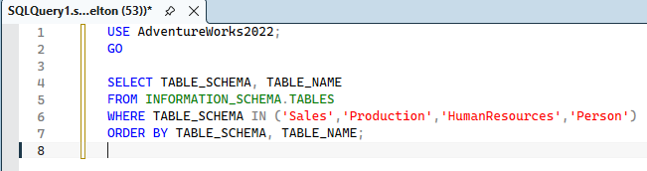
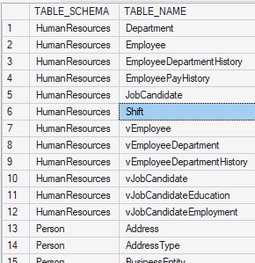

2) Look Specifically for SalesPerson
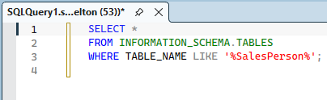

If only vSalesPerson exists — use that.
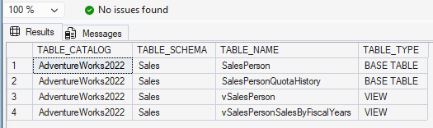

3) Inspect Table Columns
Example (inspect SalesOrderHeader):
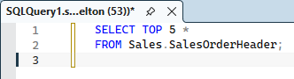

This confirms columns like OrderDate, SalesPersonID, SalesOrderID. We can repeat for any table we plan to reference.
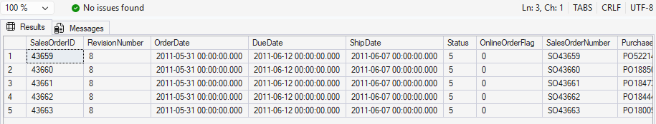

Edge Cases
1) SalesPerson is a View, Not a Table
2) Customers Can Be Person or Store
A customer linked to a person has rows in Person.Person. A customer linked to a store won’t have Person rows.
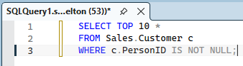
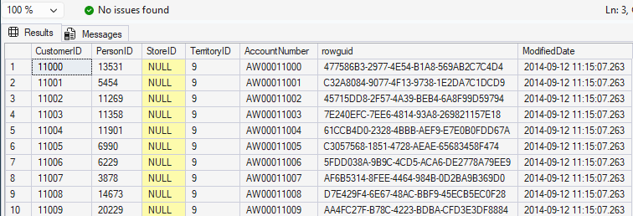
To handle both:
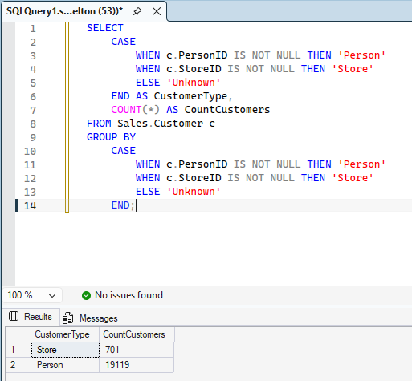

3) Some Orders May Have NULL SalesPersonID
Filtering by:
WHERE soh.SalesPersonID IS NOT NULL
prevents counting orders not tied to a rep.
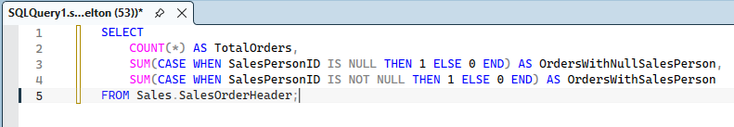
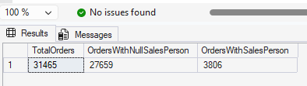
4) Latest Year Constraints
The dataset might not span multiple years - always verify:
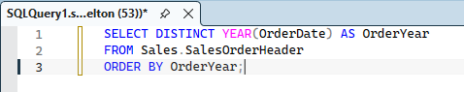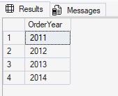

Business Queries
1) Sales Rep with Most Revenue (Latest Year)
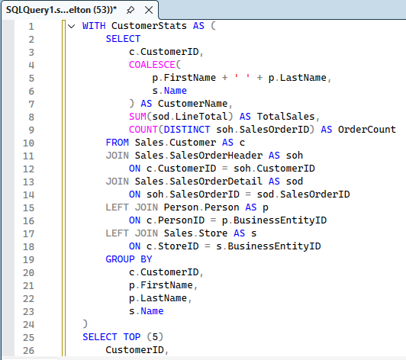
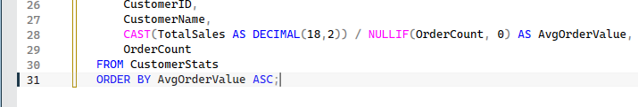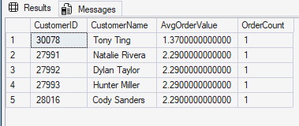

2) What is the average order value per customer? Show the five customers with the least average value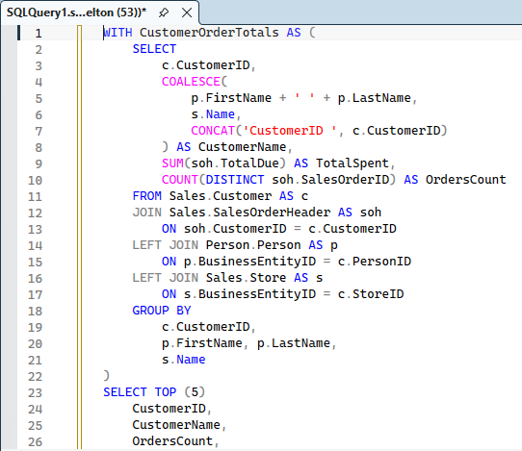s.
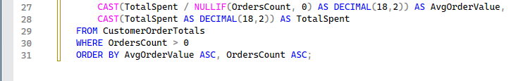
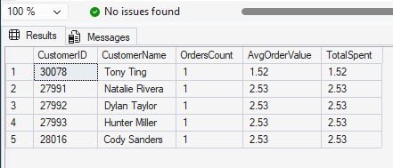

3) List the top 5 products by total sales amount.
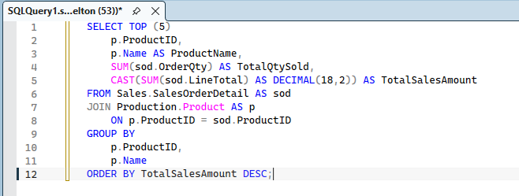
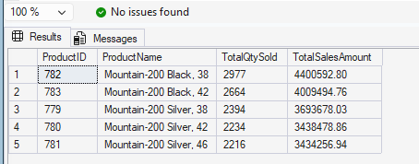
4) What is the total number of orders placed each month in the latest year?
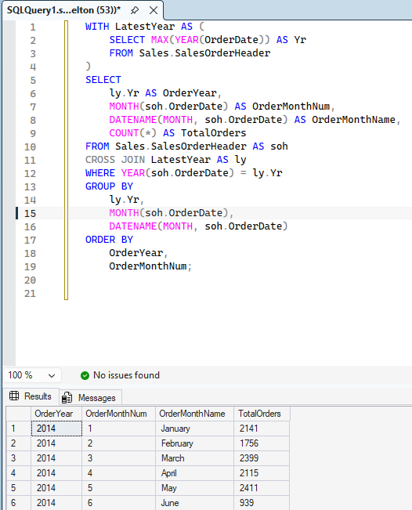
5) What is the total number of employees in each department?
